# Task 8 [4.5, M3]

**Create documentation for support and maintenance of a computer program.**

# Introduction:

This document provides guidance for support and maintenance task of the BrownBirdMS. BrownBirdMS software is developed for Brown Bird Department store to help them with their daily process. To support and maintain this software IT technician can follow this document as guidance. This documentation covers support for layout design, choice of tools, product deployment and maintenance techniques.

## Product Deployment

To deploy product first download setup file from official site or buy it from store. For installation process follow these steps.

1. Make sure system has required .Net Framework
2. Double click on Setup.exe and follow the screen steps.
3. Finish installation.
4. Open SQL Server
5. Restore back up file provided inside Setup folder.
6. Locate app.config file form installation location.
7. Edit connection string to match with the system.

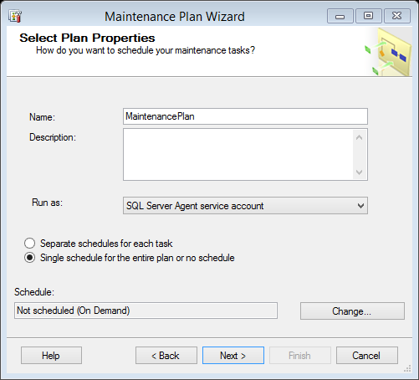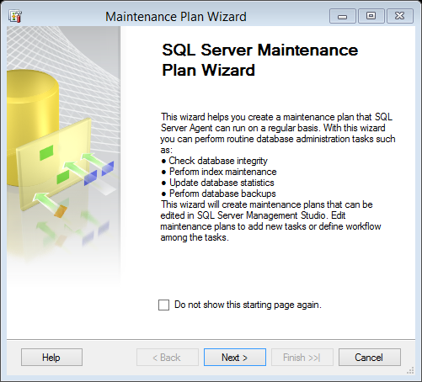

Fig: 4

Fig: 3

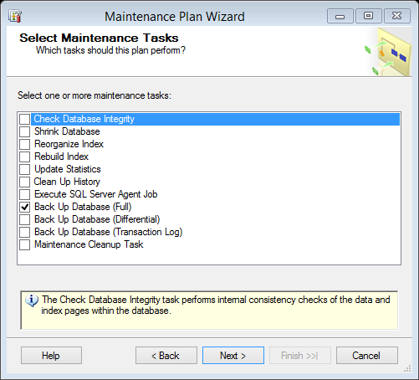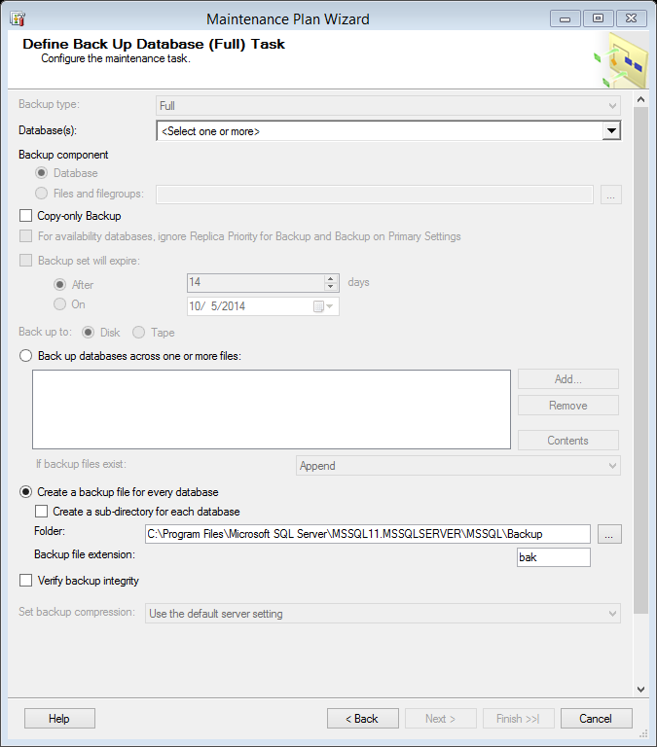

Fig: 5

Fig: 6

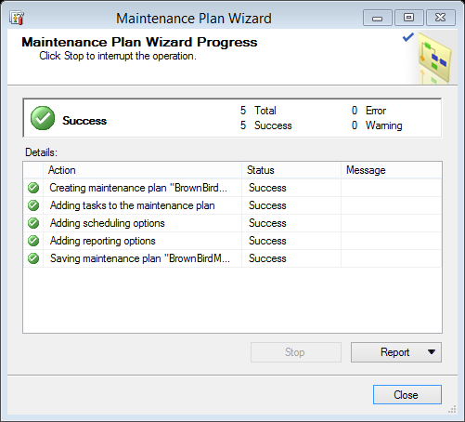

Fig: 7